|  |
| --- |
| **Phase-6**  **Full stack java developer**  **Capstone project**  **Project :-Food Box**  **(Application Screenshots)** |

**Version History**

|  |  |
| --- | --- |
| Author | K.Swathi |
| Purpose | Screenshots of the Application |
| Date | 01/02/2022 |
| version | 1.0 |

**Git hub:-**

**Login to github by providing the email address and password**

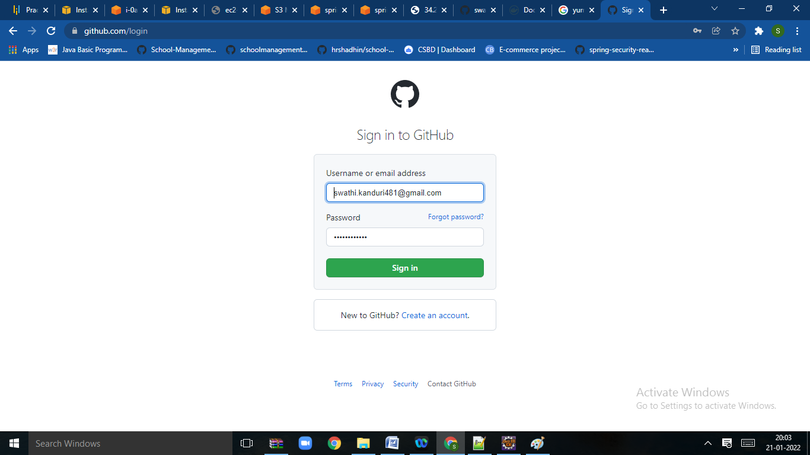

**Click on sign in option to open the page**

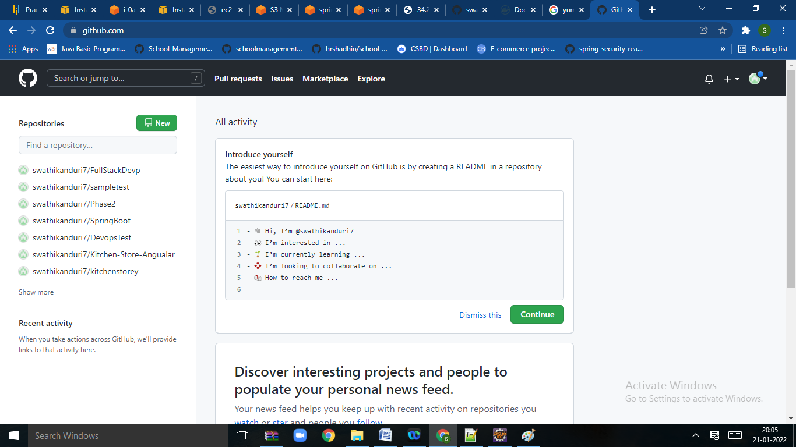

**Click on new repository to create new repository**

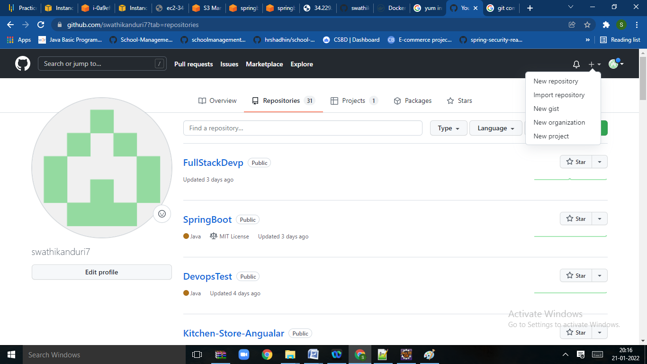

**Give the repository name and select create repository**

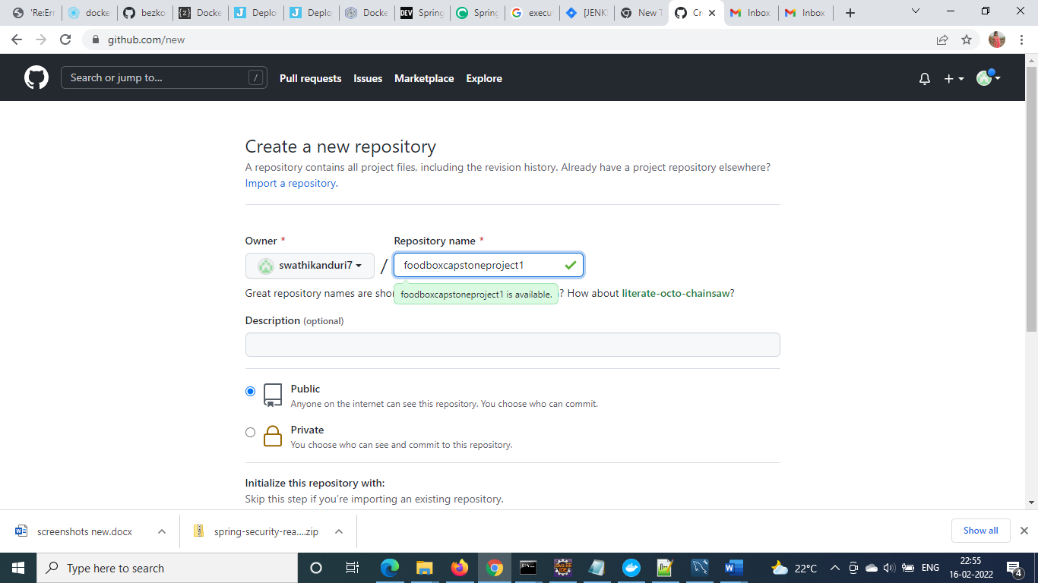

**Steps to Push the code to Git Hub Repository**

* Open your command prompt and navigate to the folder where you have

created your files.

**cd <folder path>**

* Initialize repository using the following command

**git init**

* Add all the files to your git repository using the following command

**git add .**

* Commit the changes using the following command

**git commit . –m<commit message>**

* Push the files to the folder you initially created using the following command

**git push -u origin master**

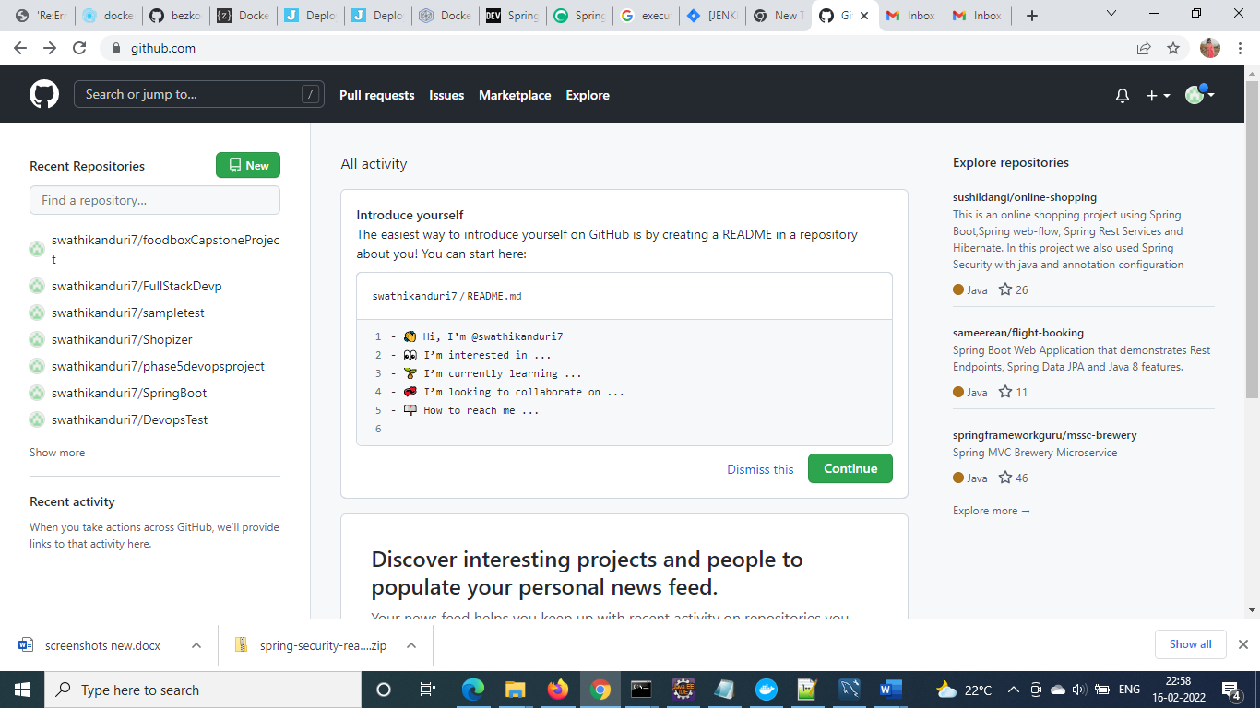

**Code pushes to the git hub**

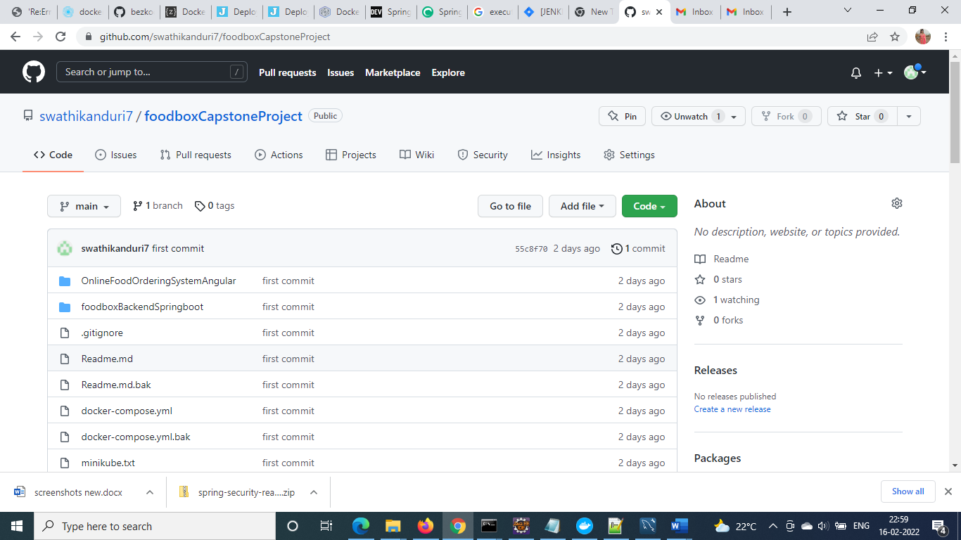

**Jenkins Job**

**Jenkins installation in Ec2 instance:**

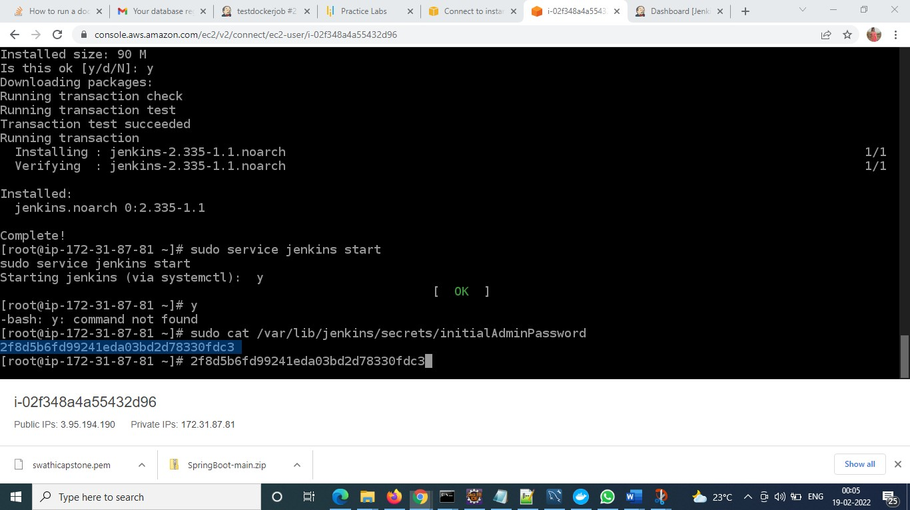

**Access Jenkins from public IP:**

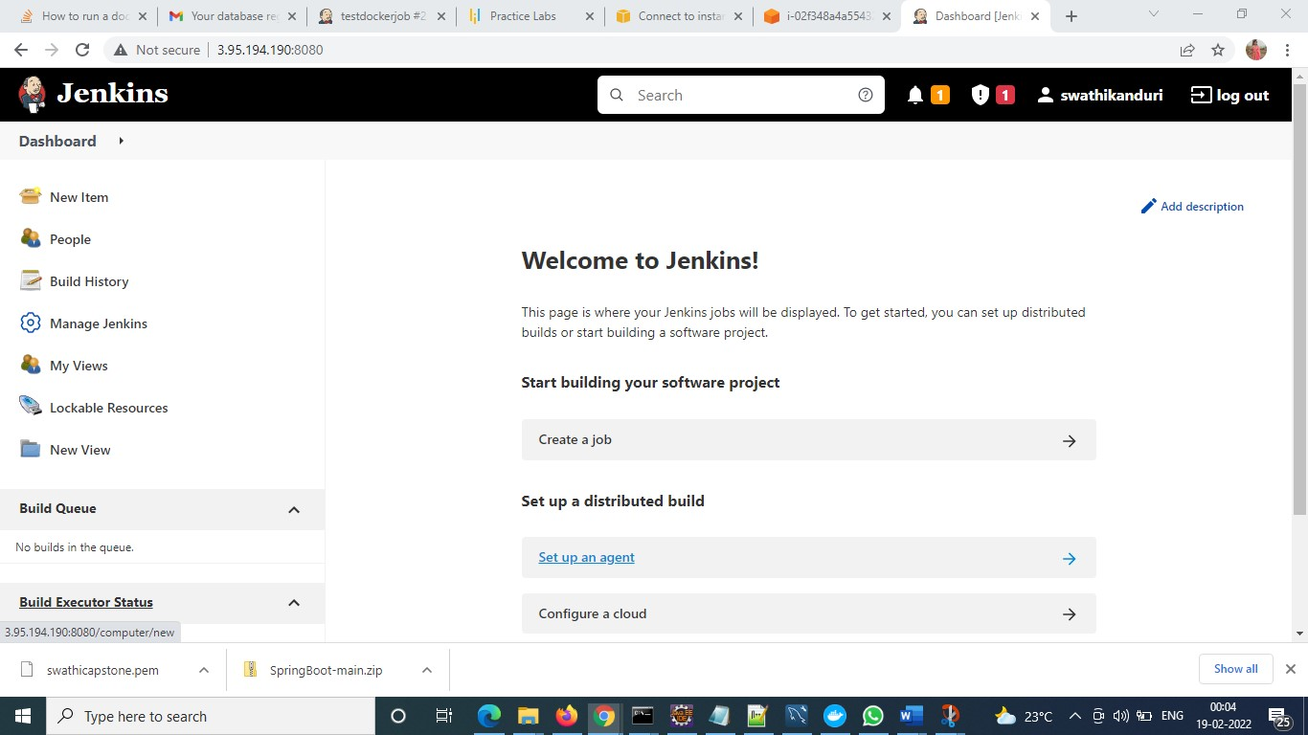

**Install Docker on EC2 Instance:**

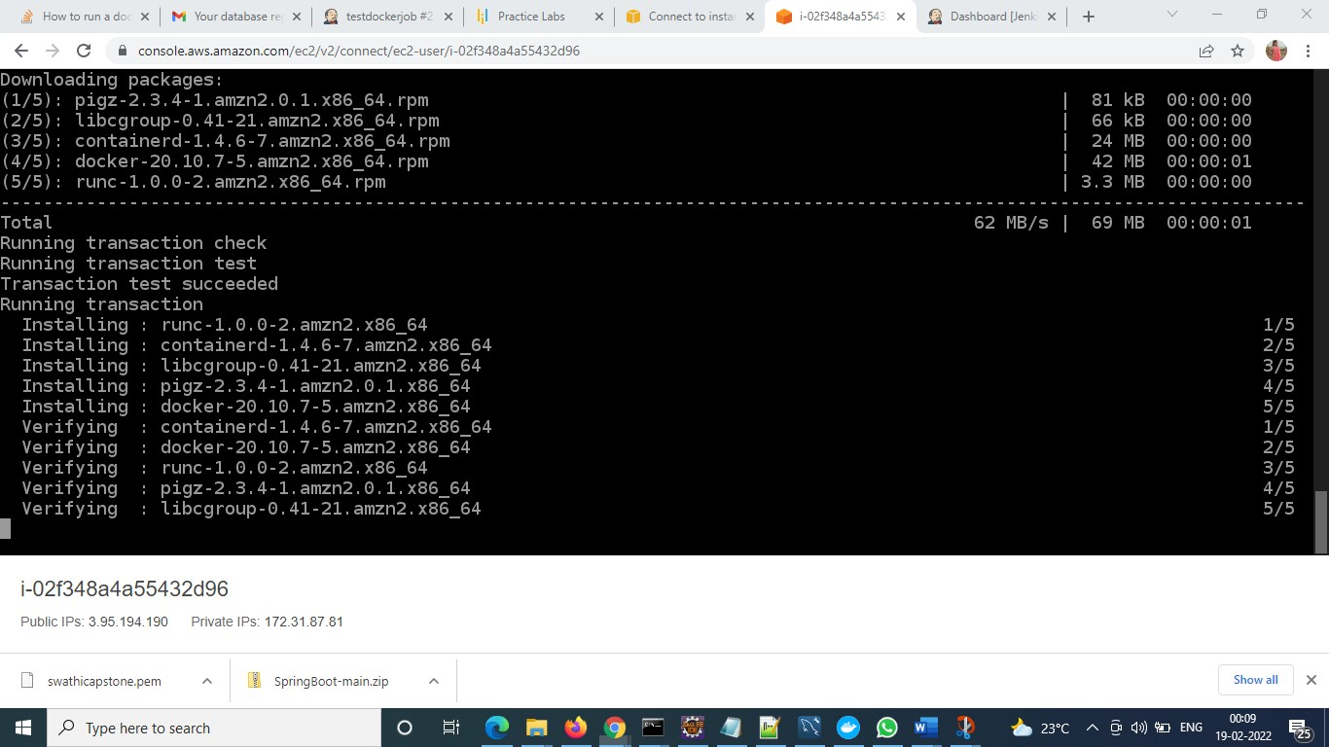

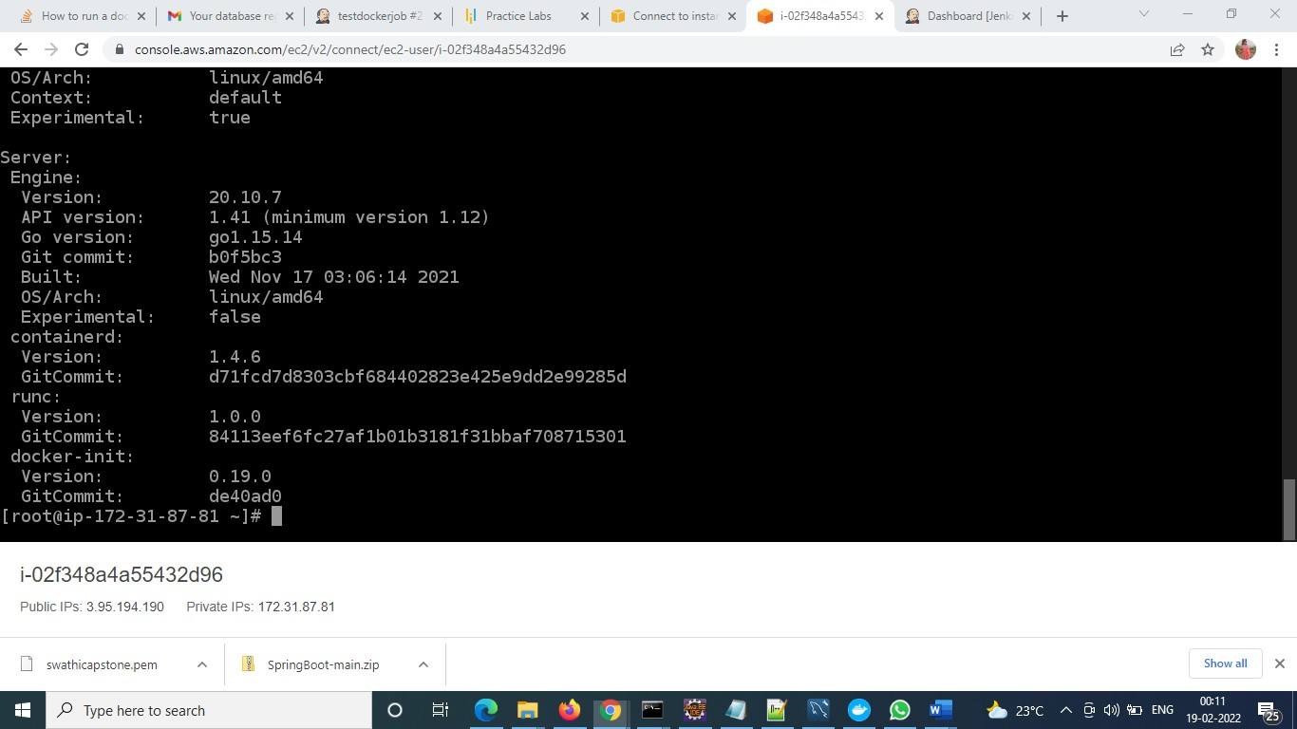

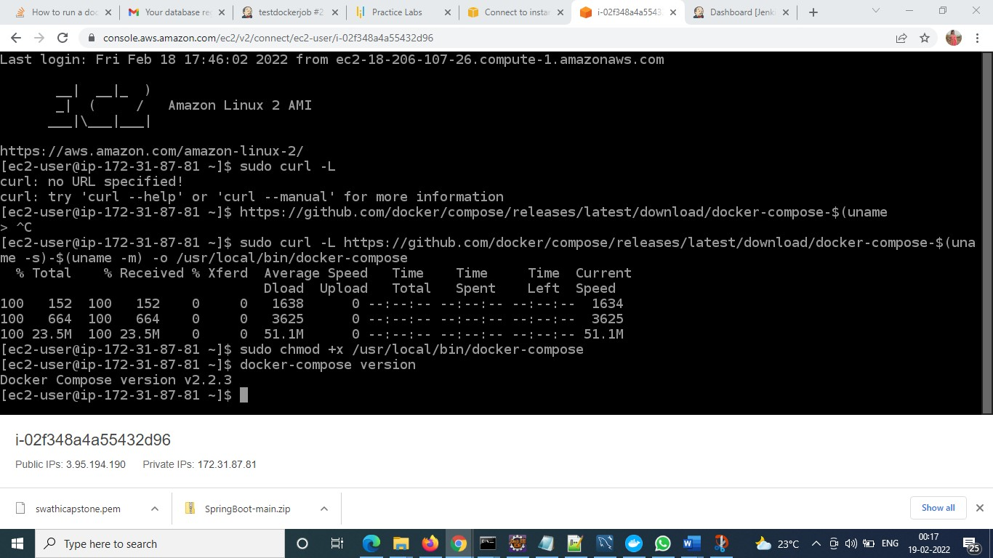

**Configure Jenkins Job for Capstone Project**

**step1:- New item**

**give the name of the job**

**select free project**

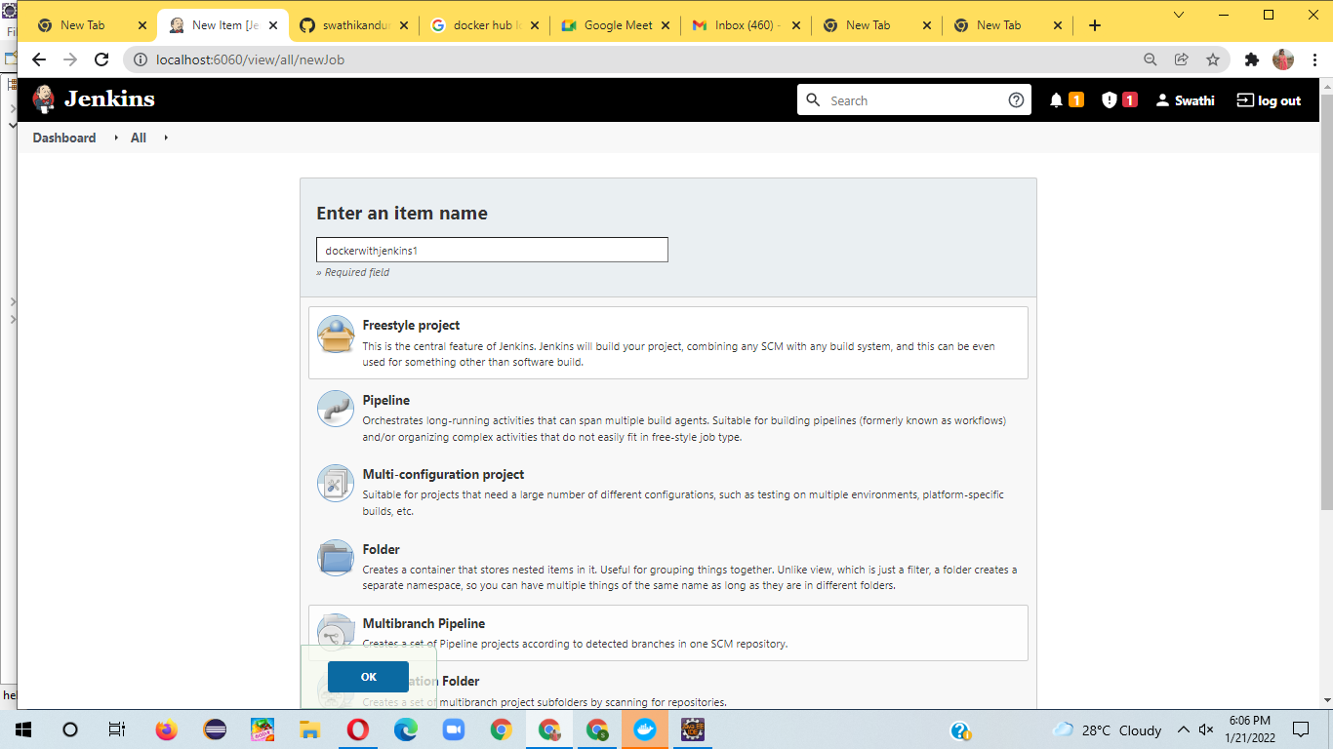

**config git url:-**

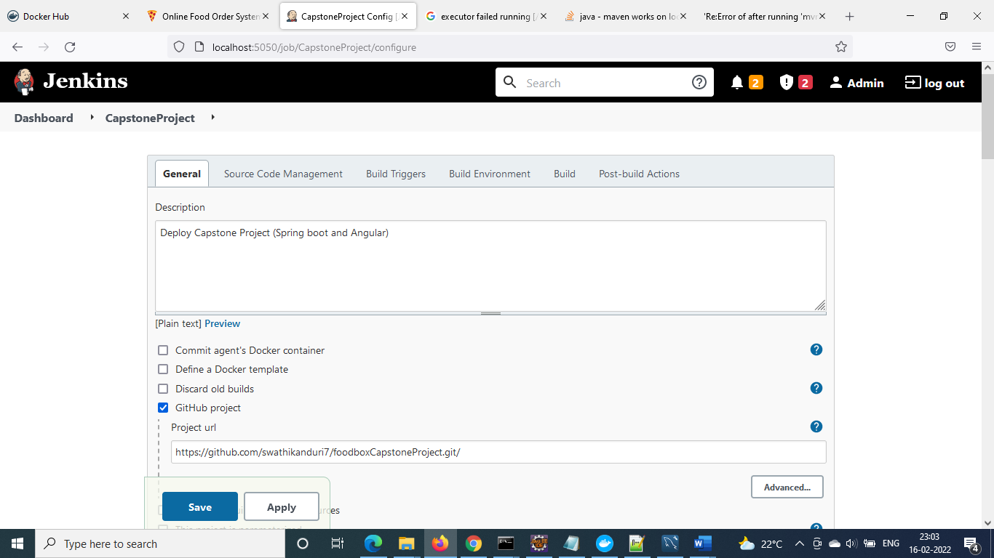

**config scm**

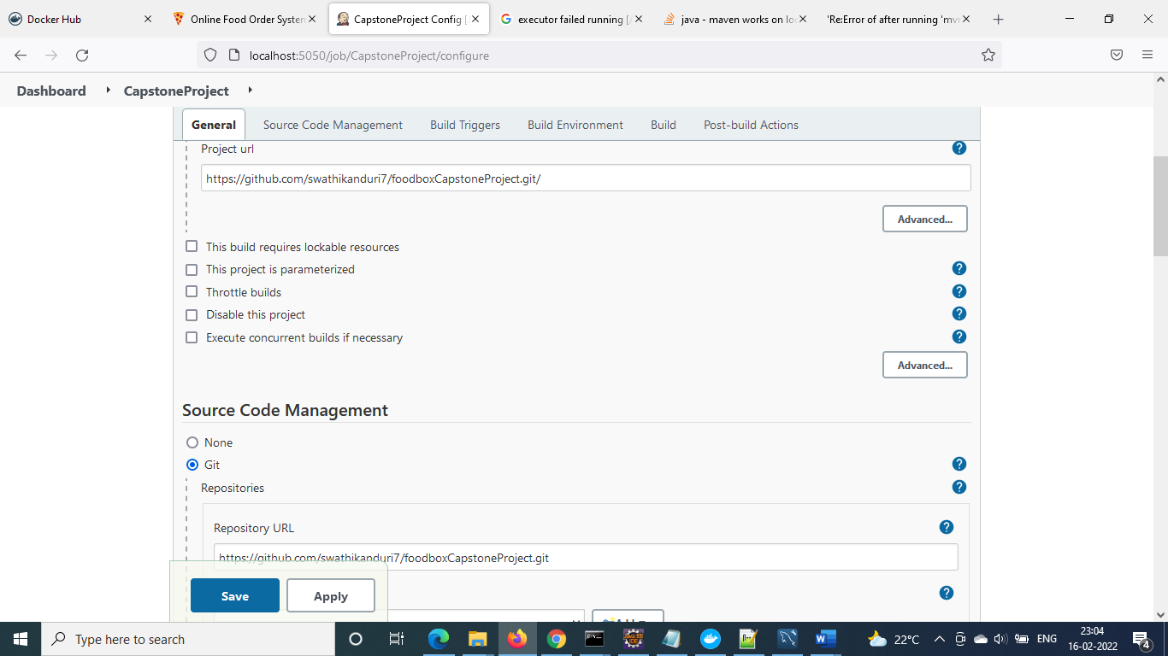

**config build trigger rule, branch name**

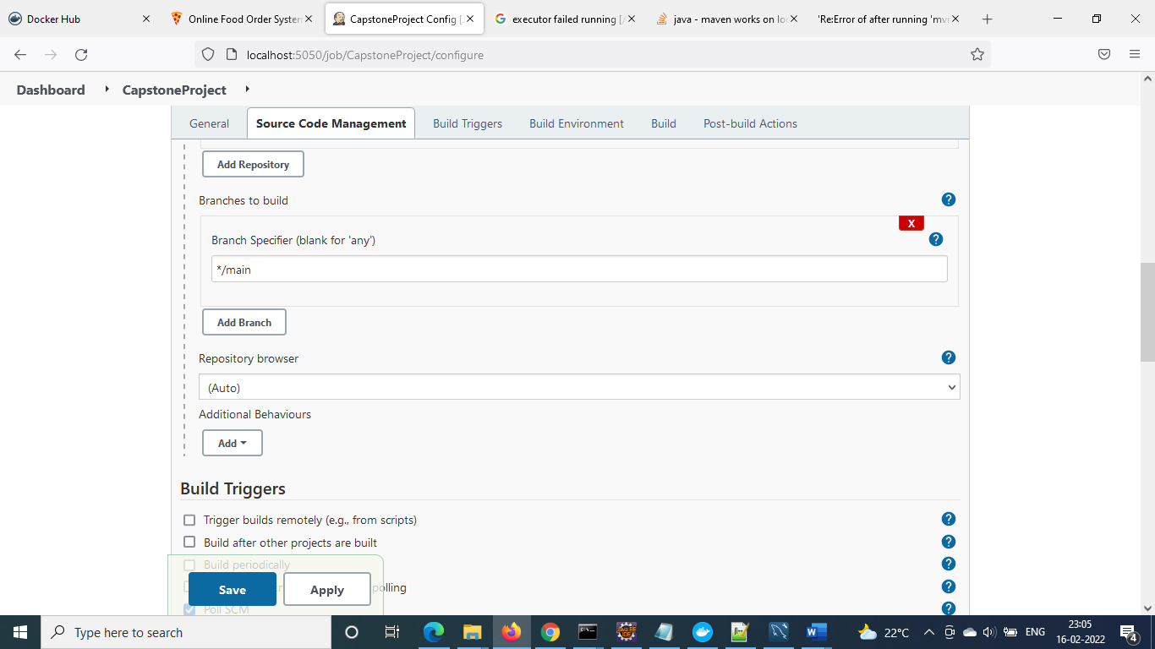

**Build Triggers**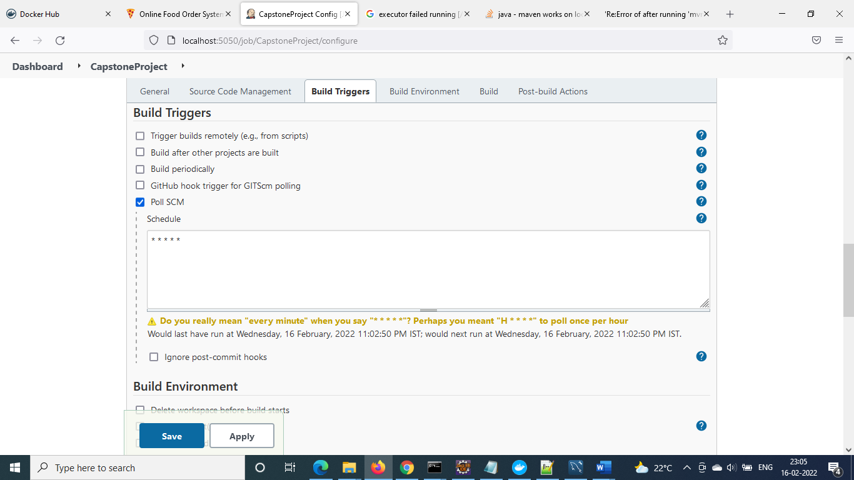

**configure docker build and push and click on save to update the details**

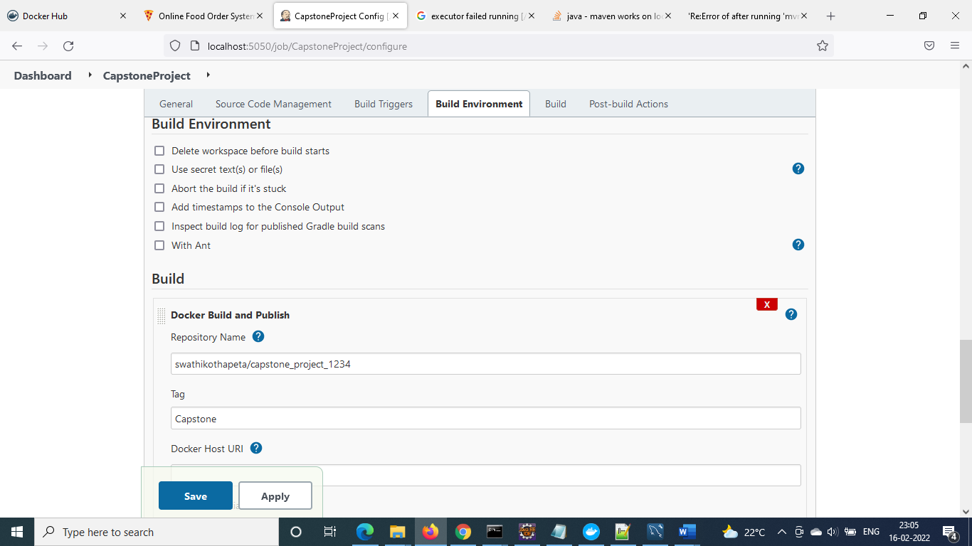

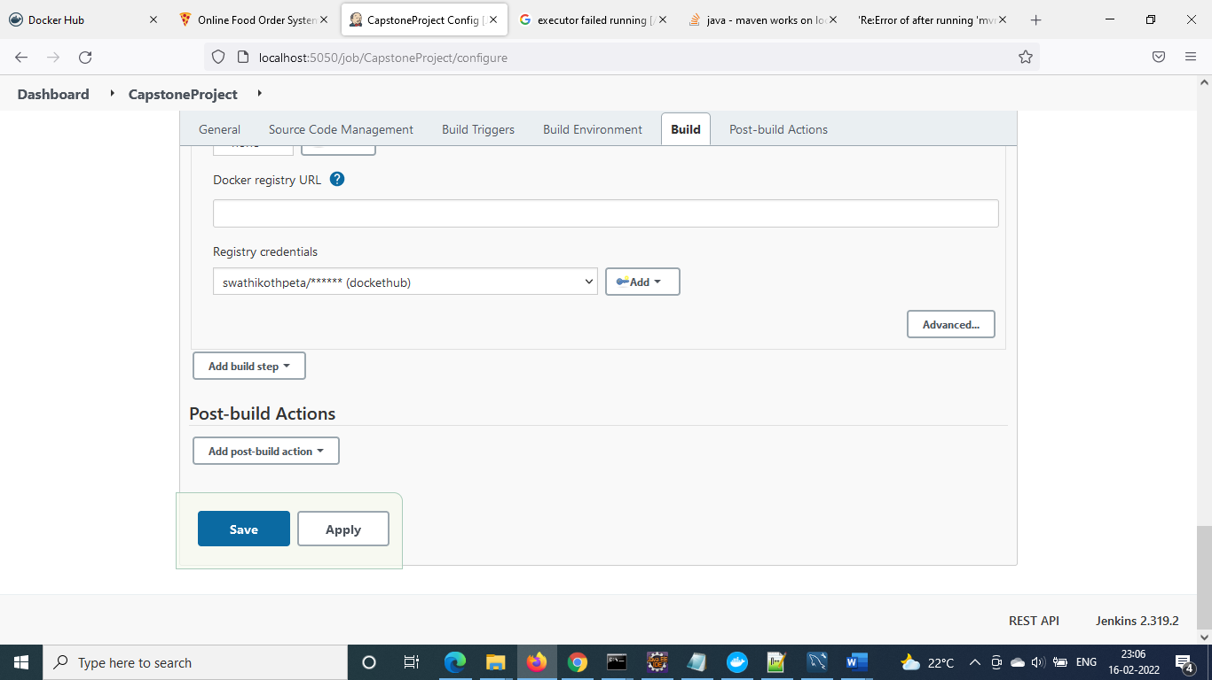

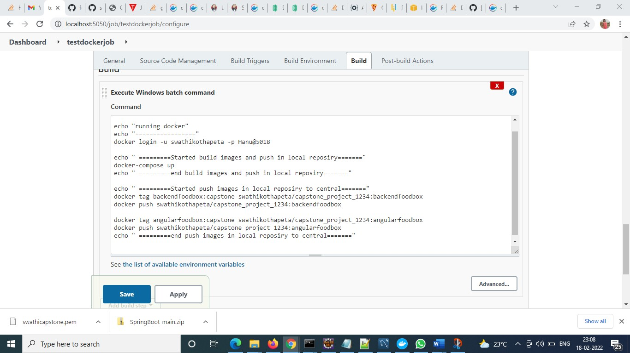

**Trigger jenkins job, using build now**

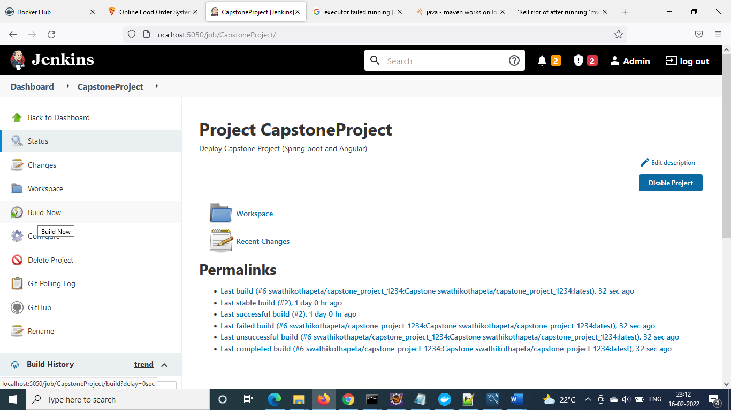

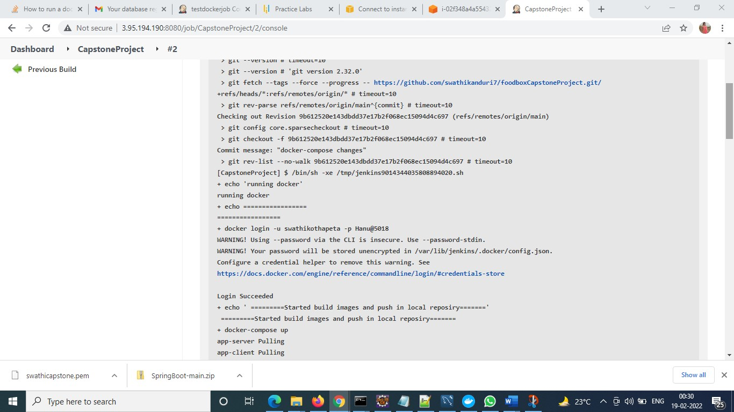

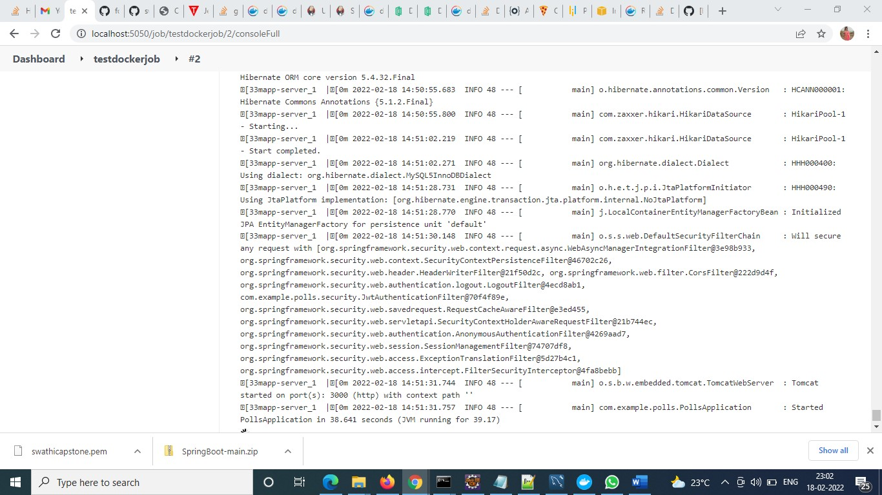

When executing local:

D:\swathi\foodBoxCapstoneproject>docker tag backendfoodbox:capstone swathikothapeta/capstone_project_1234:backendfoodbox

D:\swathi\foodBoxCapstoneproject>docker image ls

REPOSITORY TAG IMAGE ID CREATED SIZE

backendfoodbox/backend latest d53856e9114c 2 hours ago 765MB

backendfoodbox capstone d53856e9114c 2 hours ago 765MB

backendfoodbox latest d53856e9114c 2 hours ago 765MB

swathikothapeta/capstone_project_1234 backendfoodbox d53856e9114c 2 hours ago 765MB

swathikothapeta/capstone_project_1234 latest d53856e9114c 2 hours ago 765MB

testdockerjob_app-client latest dd44391db884 2 hours ago 123MB

testdockerjob_app-server latest e99d9ee45b0c 2 hours ago 721MB

angularfoodbox capstone 0095d904f9da 6 hours ago 123MB

angularfoodbox latest 0095d904f9da 6 hours ago 123MB

swathikothapeta angularfoodbox 0095d904f9da 6 hours ago 123MB

mysql 5.7 0712d5dc1b14 3 weeks ago 448MB

D:\swathi\foodBoxCapstoneproject>docker push swathikothapeta/capstone_project_1234:backendfoodbox

The push refers to repository [docker.io/swathikothapeta/capstone_project_1234]

033773ffed73: Layer already exists

9325d0a6d404: Layer already exists

7cd63f3a6298: Layer already exists

b1ffb0afe857: Layer already exists

82b8b9ba0d1c: Layer already exists

48745260b181: Layer already exists

ab19b46e9384: Layer already exists

080ef0ba5cc0: Layer already exists

d08e6b97bf21: Layer already exists

3054497613e6: Layer already exists

d35dc7f4c79e: Layer already exists

dabfe5b2ea81: Layer already exists

5e6a409f30b6: Layer already exists

backendfoodbox: digest: sha256:823405ec323fe9468ce80e00d92f98b833103f67a92dac211a0ca6caf851e7db size: 3052

D:\swathi\foodBoxCapstoneproject>docker tag angularfoodbox:capstone swathikothapeta/capstone_project_1234:angularfoodbox

D:\swathi\foodBoxCapstoneproject>docker push swathikothapeta/capstone_project_1234:angularfoodbox

The push refers to repository [docker.io/swathikothapeta/capstone_project_1234]

e732cbac0f08: Pushed

b165562e5fc3: Pushed

fbe0fc9bcf95: Pushed

f1b5933fe4b5: Pushed

angularfoodbox: digest: sha256:9eedf5b174ef90bad30736ee43f30a03f558bf95522fb467f3462c1fbd492e4f size: 1158

Local Repository:

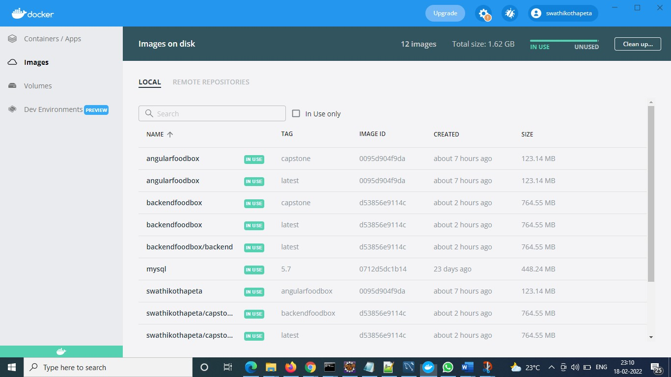

Remote Repository:

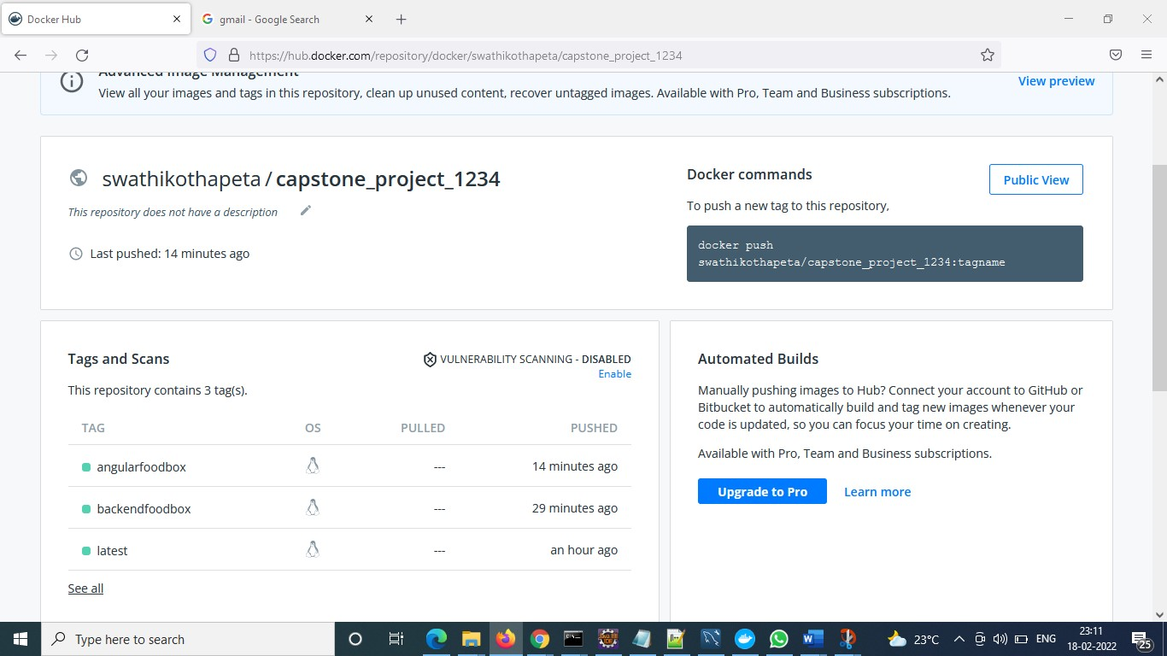

**Admin Login**

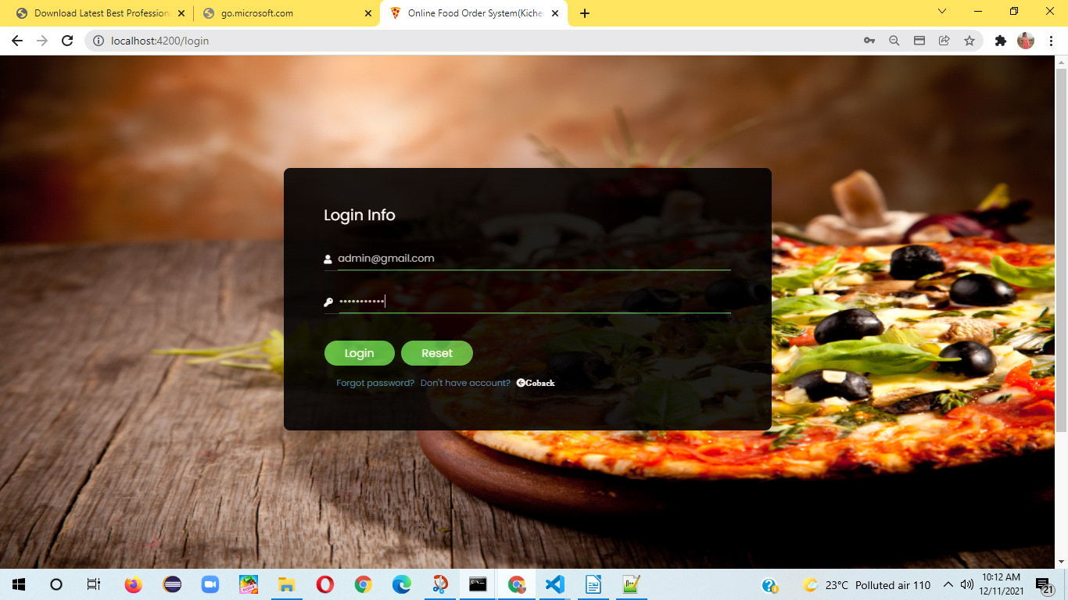

**After Logon admin home will display orders list:-**

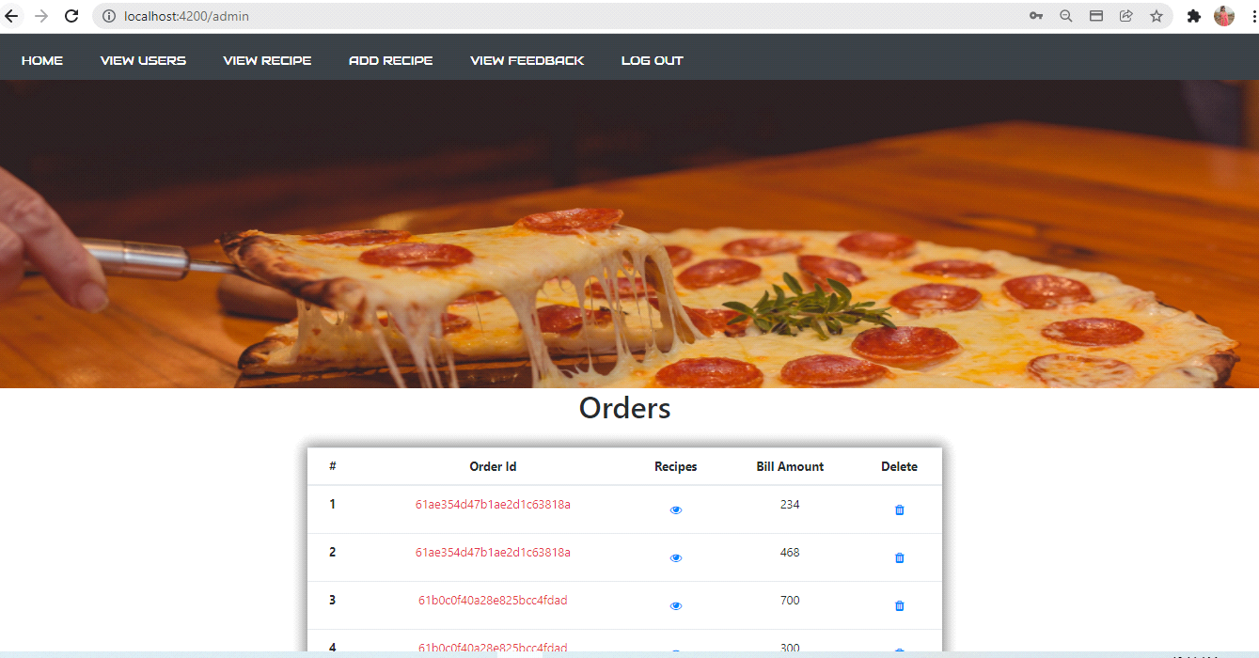

**3**

**Admin Home:**

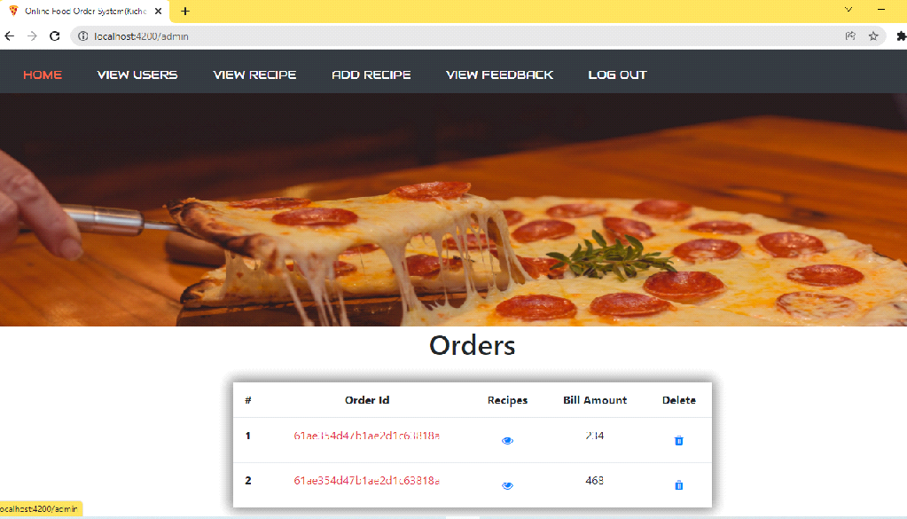

**View users:-**

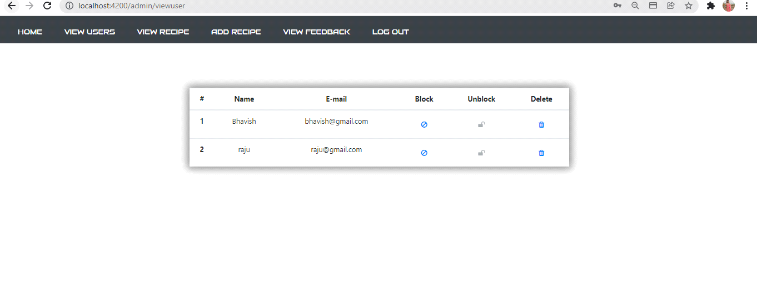

**4**

**Add Recipe**

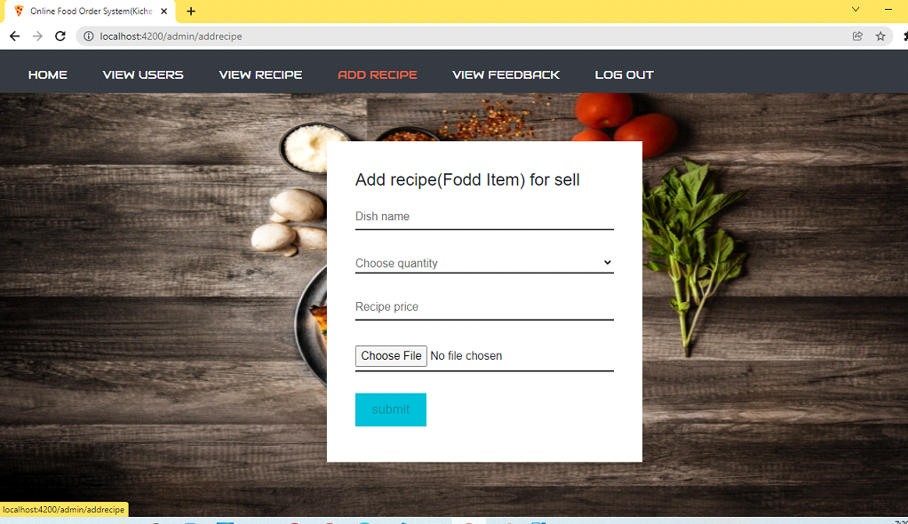

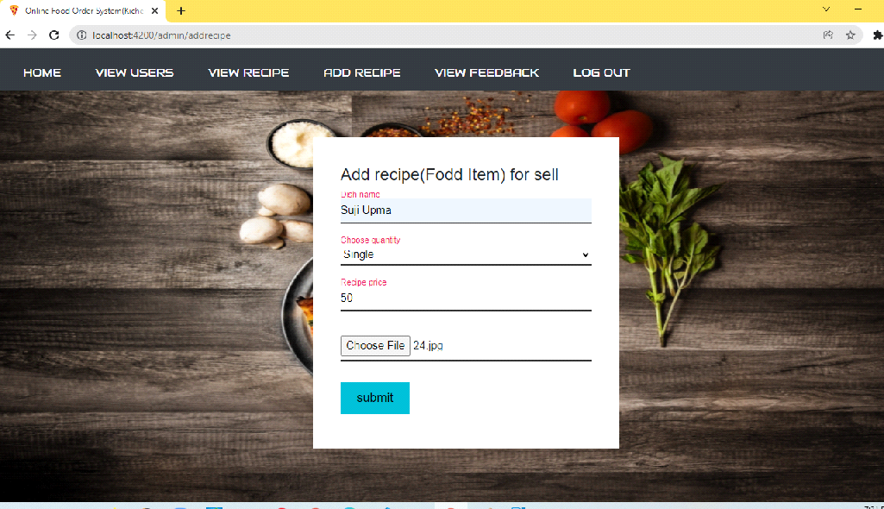

**5**

**view recipe**

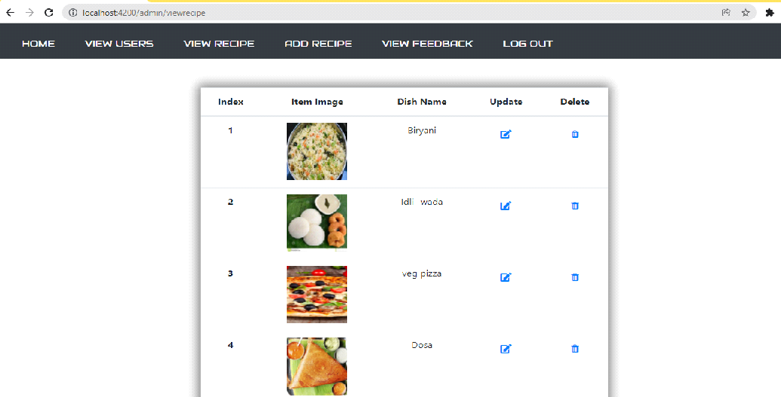

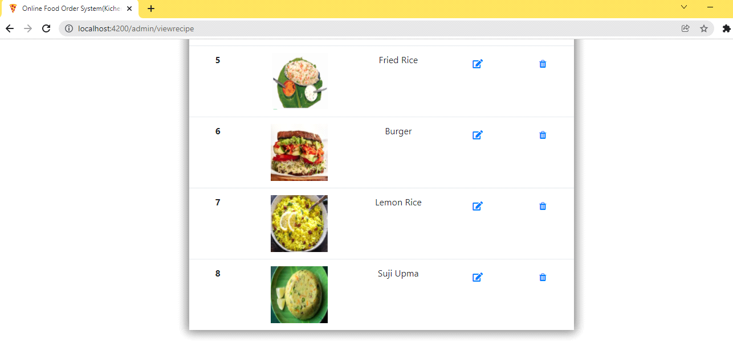

**6**

**View Feed back**

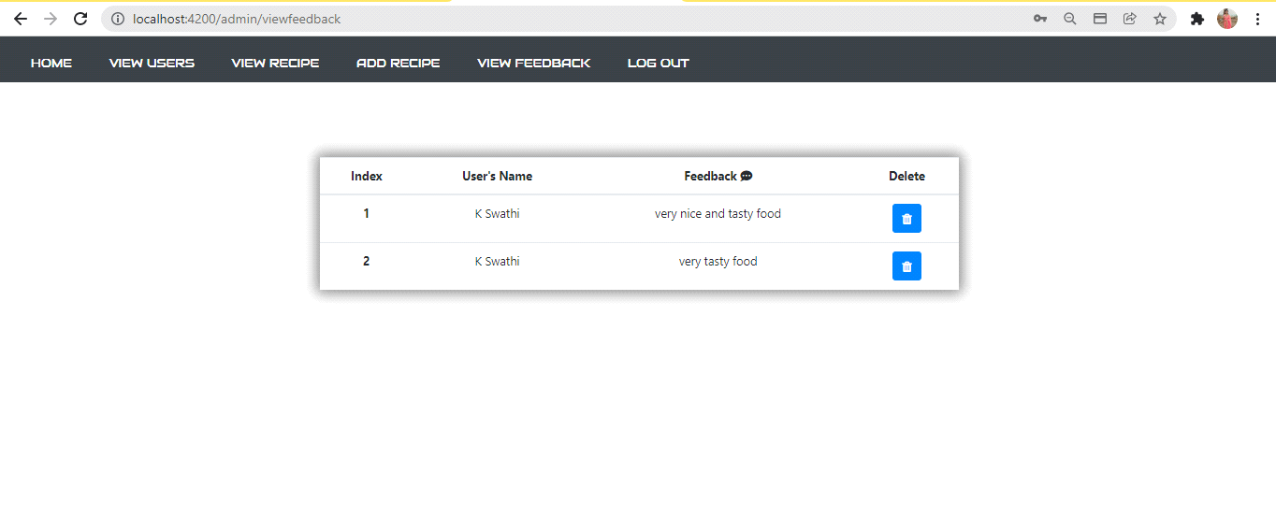

**7**

**User Flows:**

**1)Web home page**

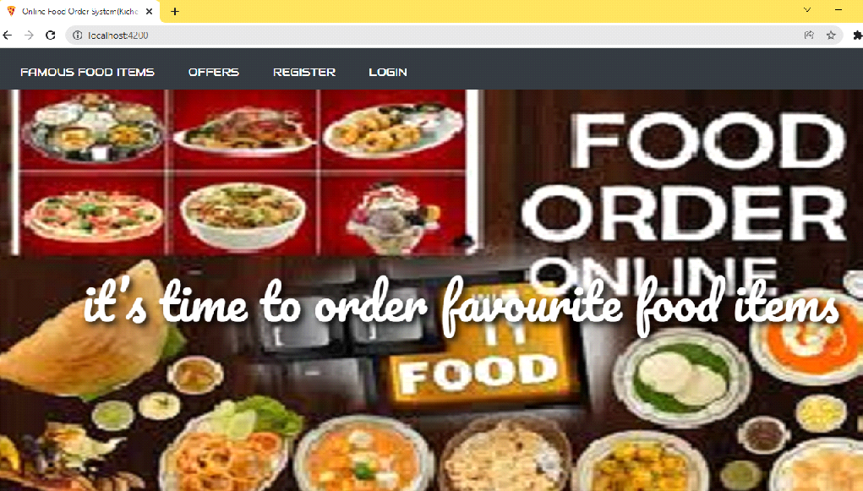

**2) View famous food items**

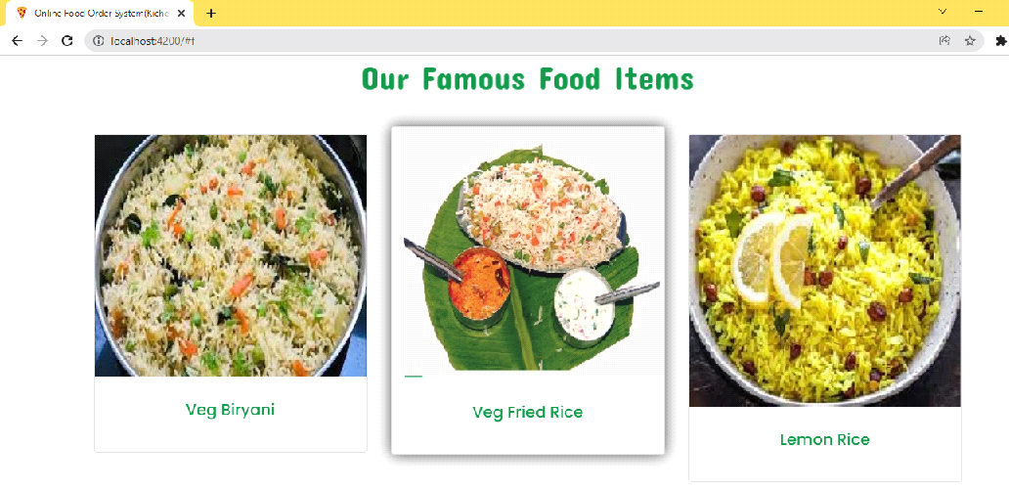

**8**

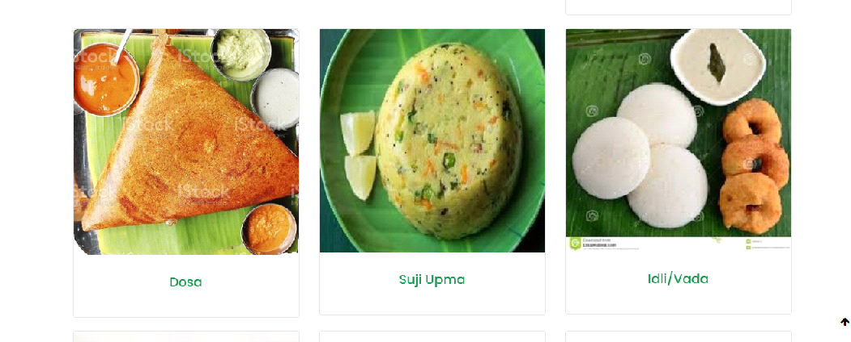

**Check for offers**

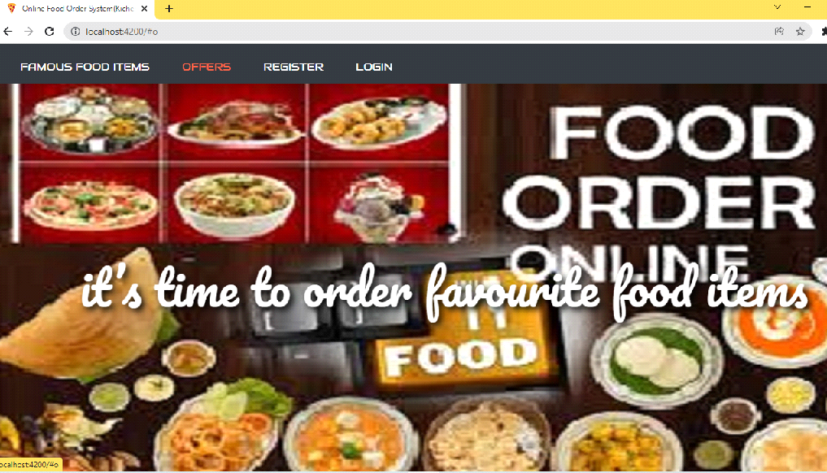

**9**

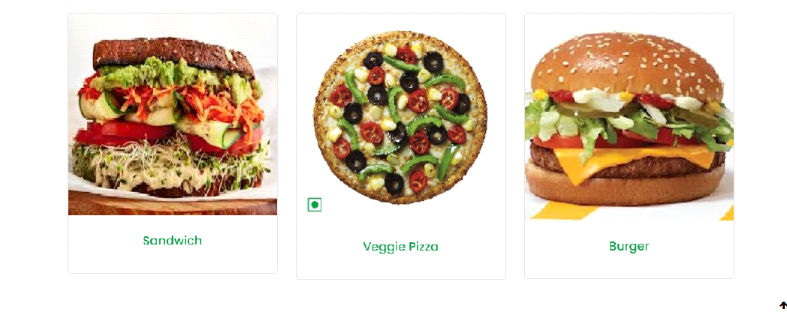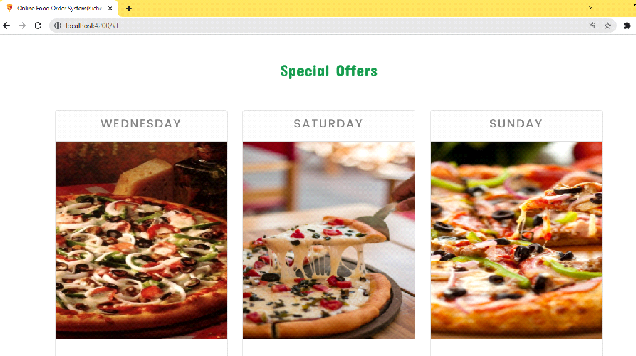

**User Registration (click on register)**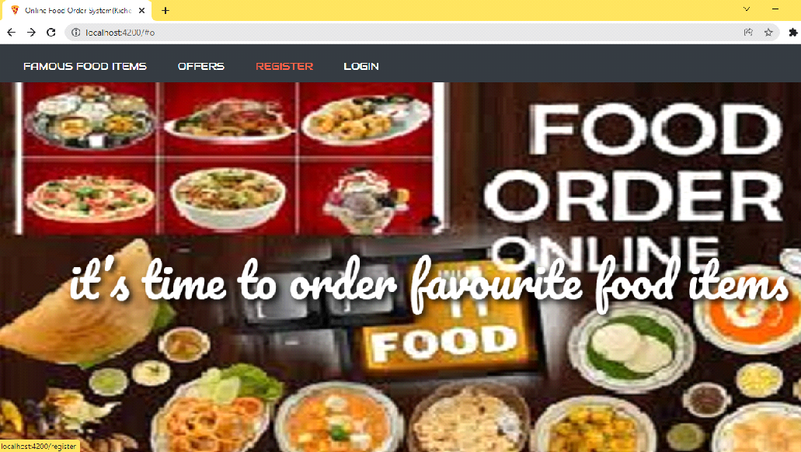

**10**

**Provide User details for Registration**

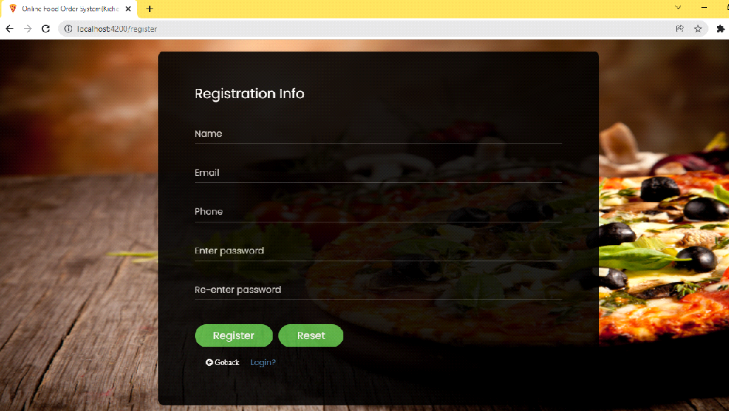

**Validating user form:**

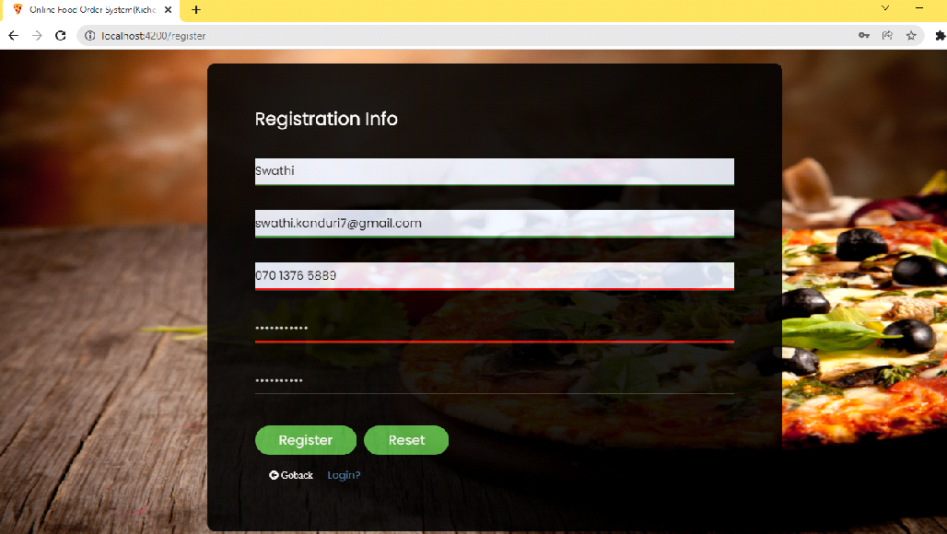

**11**

**After Successful Registration it will redirect to login page**

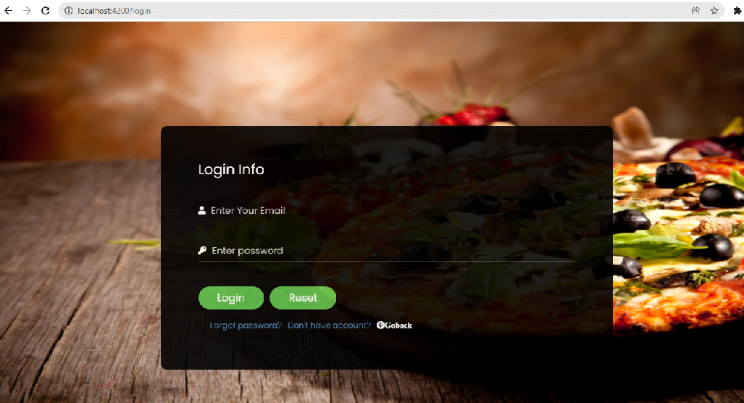

**User Login:-**

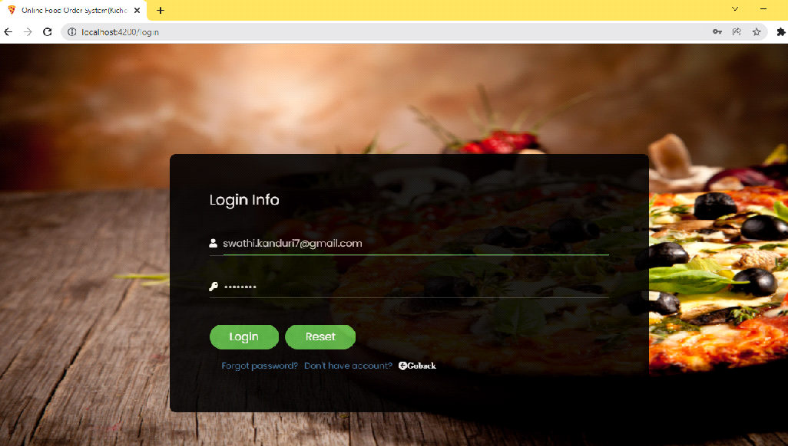

**User home-**

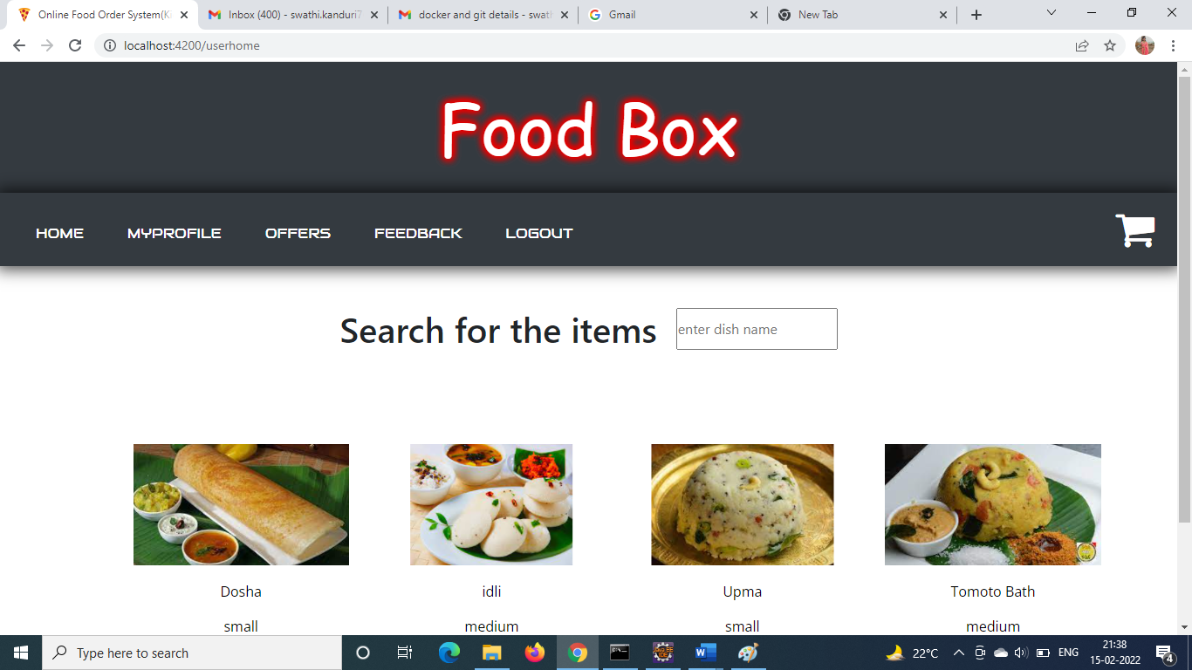

**Search for the items:**

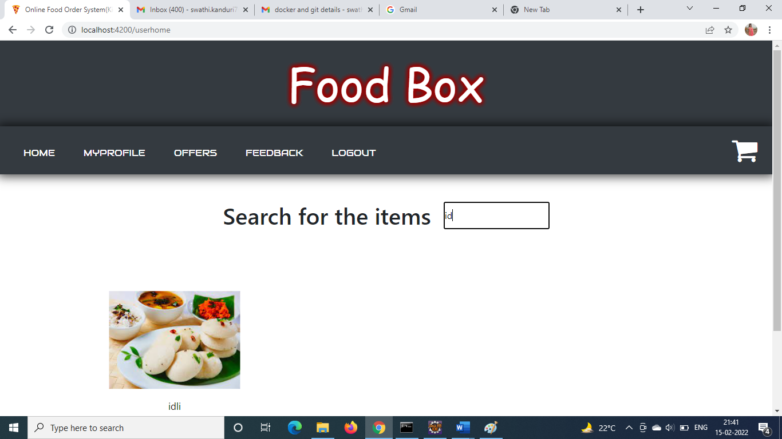

**Buy Now:**

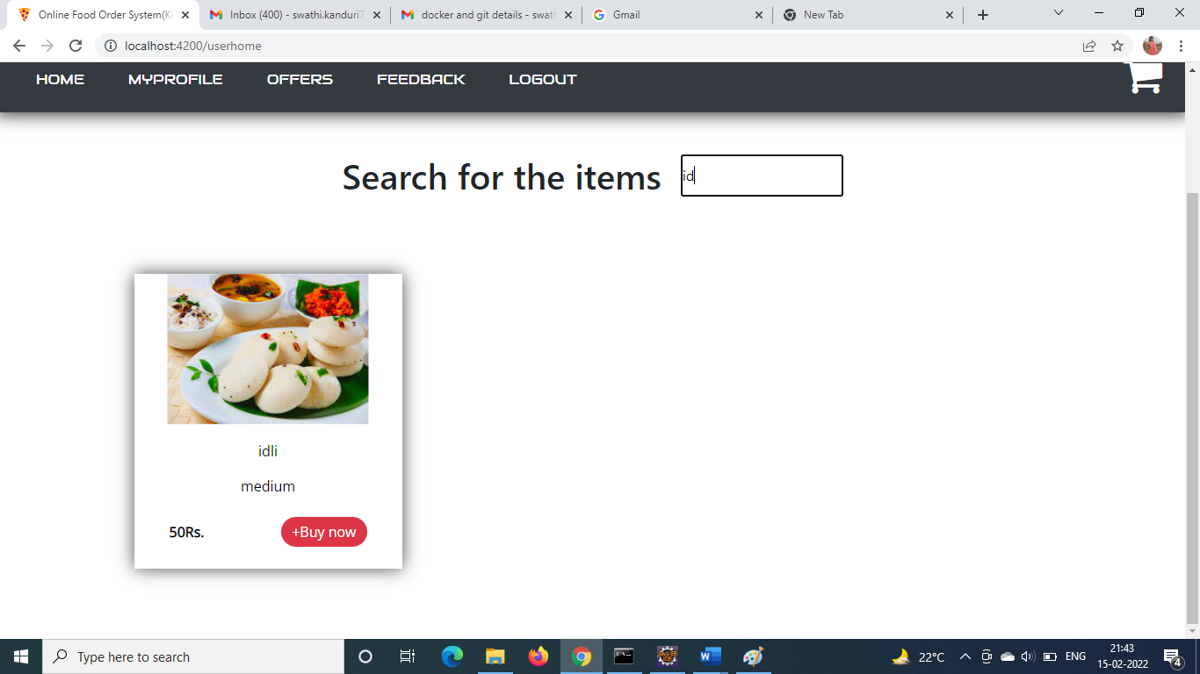

**Go to Cart to check out:**

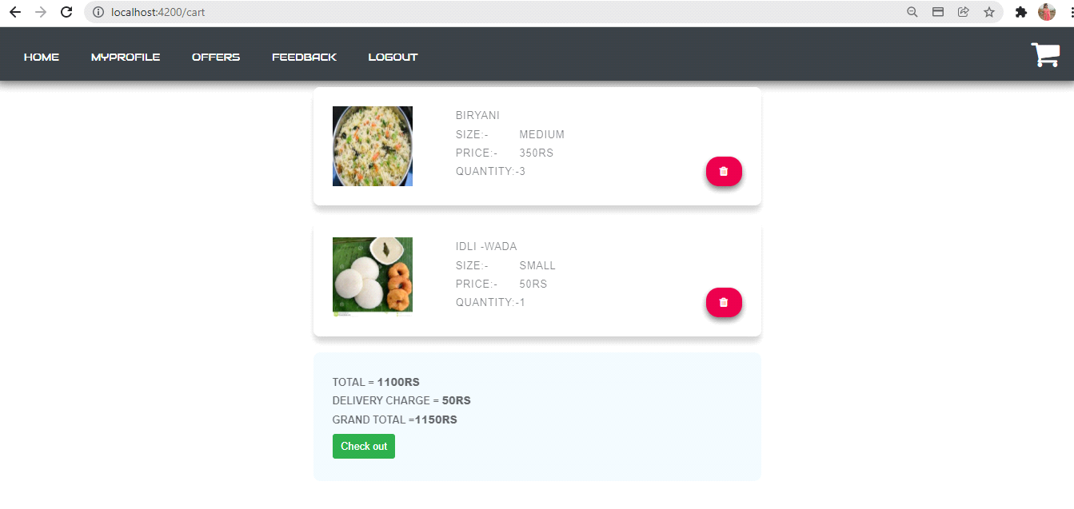

**Click on check out for payment:**

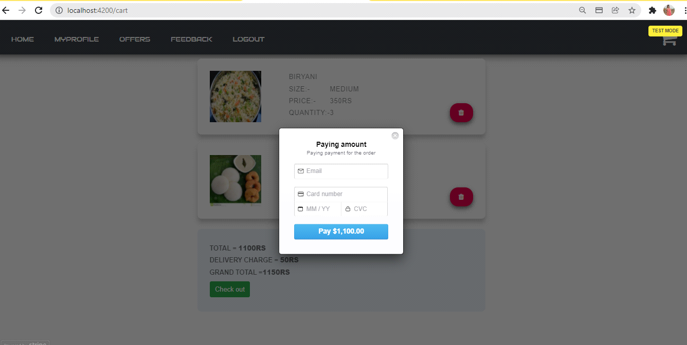

**Provide the details (debit/credit card)**

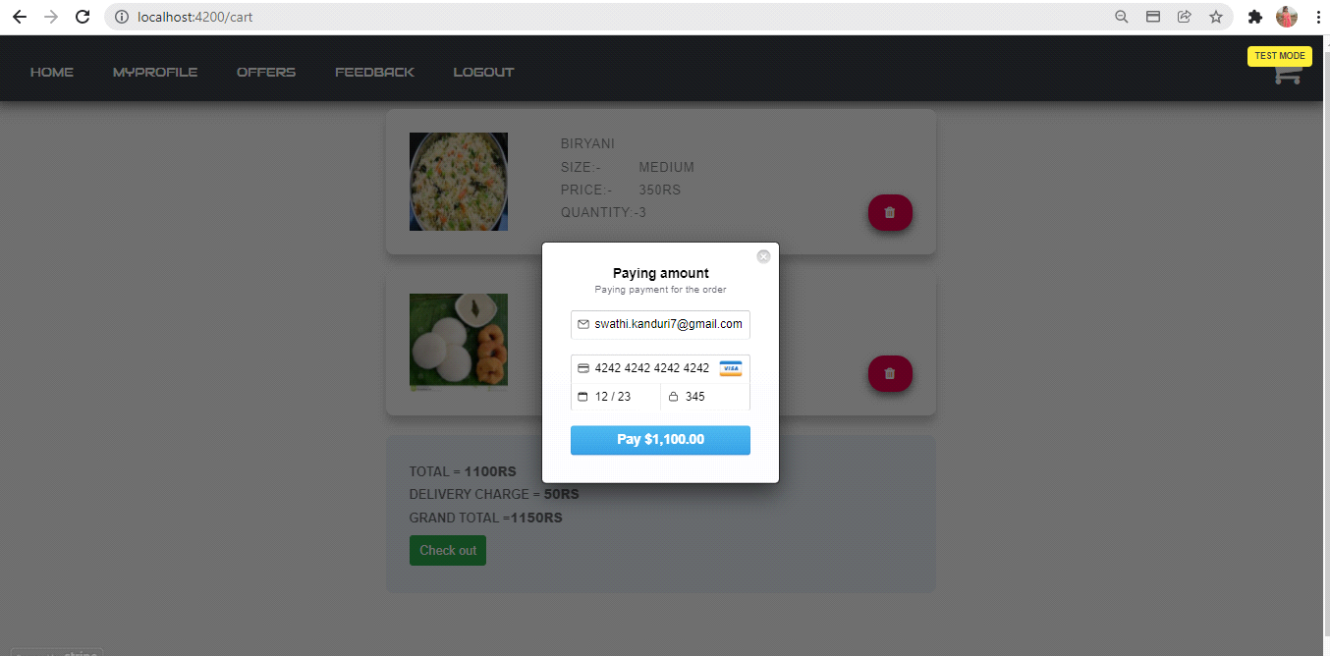

**payment successful:-**

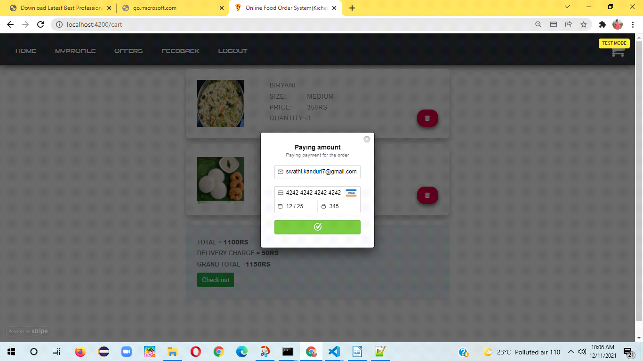

**Placed order successfully Confirmation display:**

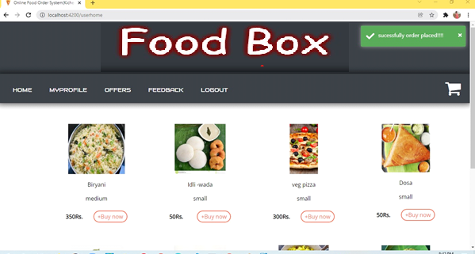

**Click on my profile**

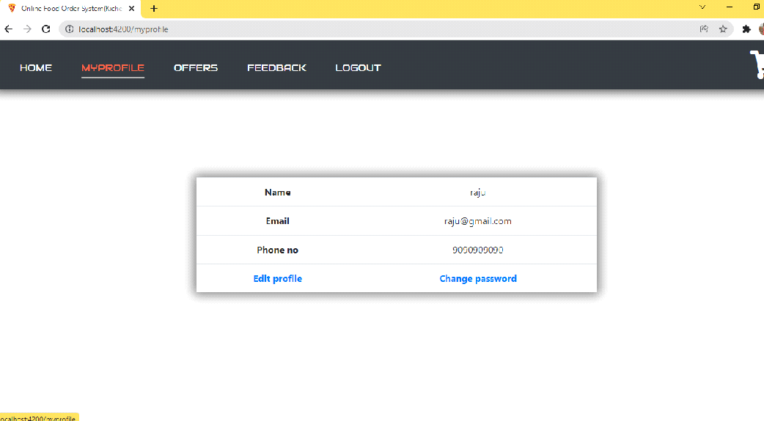

**click on edit profile**

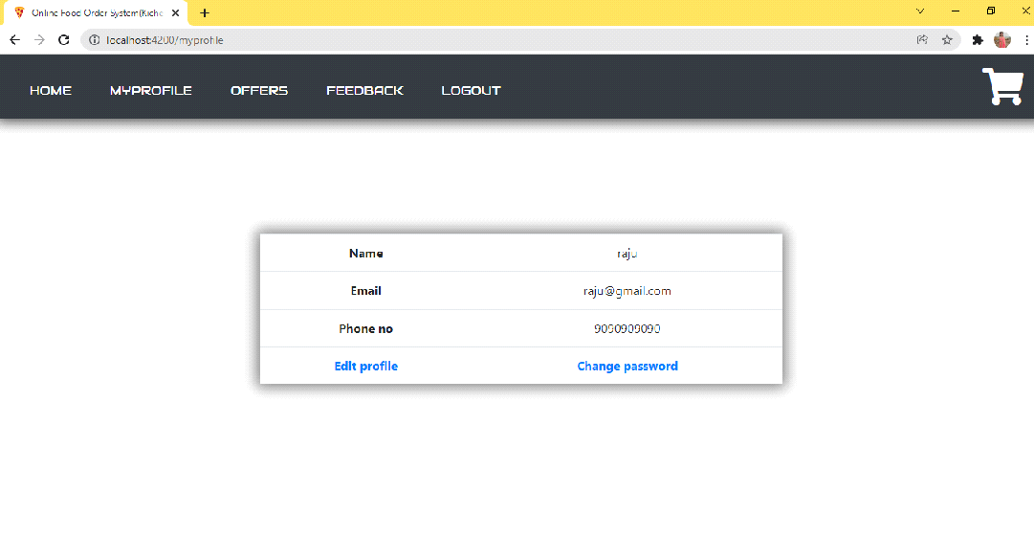

**Edit profile**

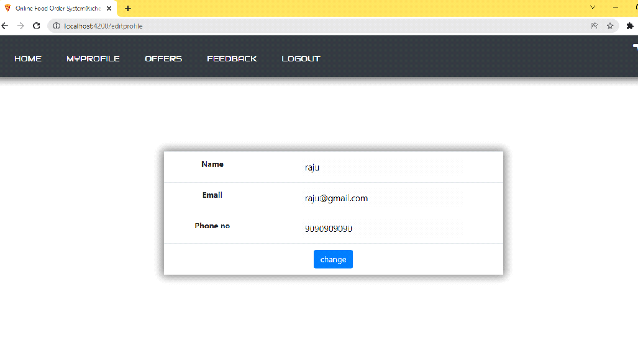**To change password**

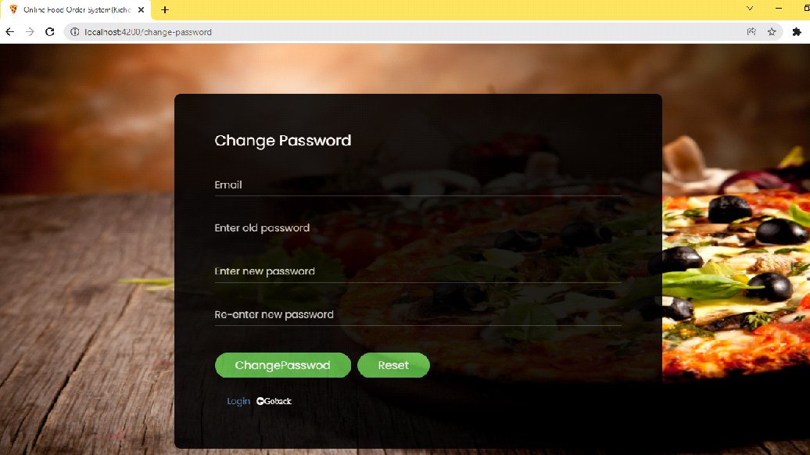

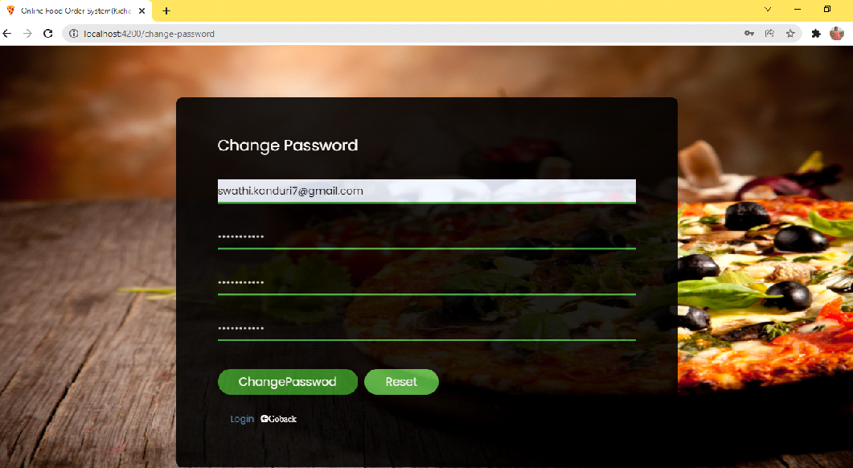

**Forgot password:-**

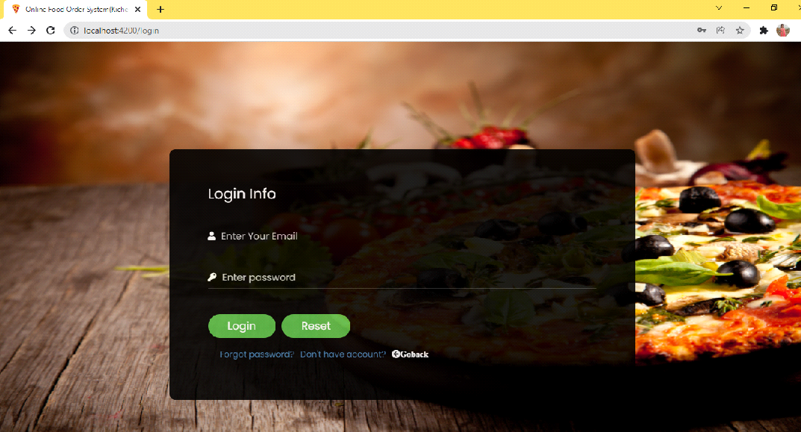

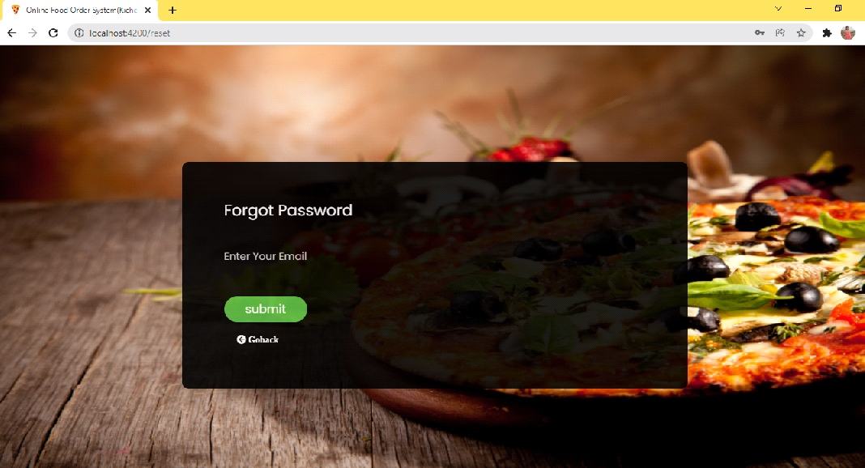

**To provide Feedback:-**

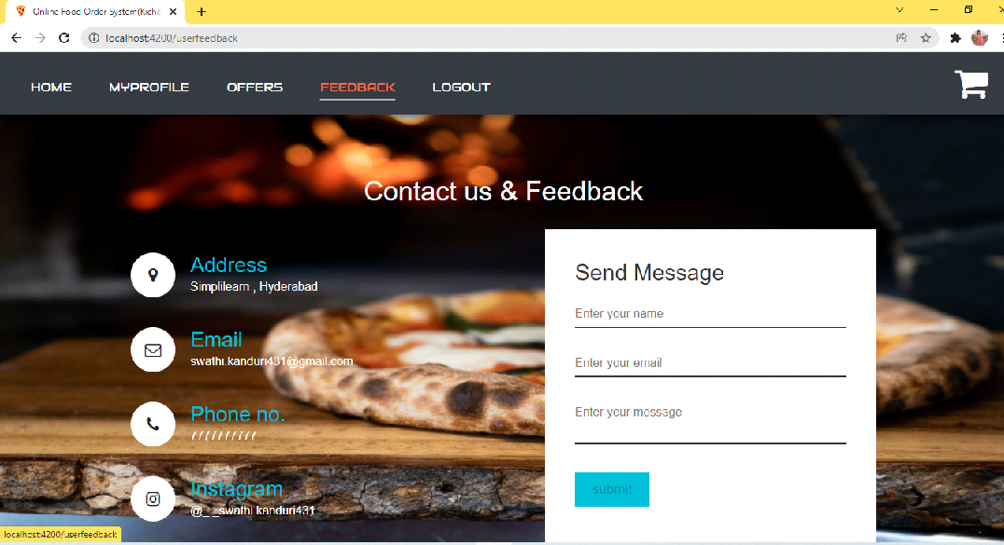

**Contact and feedback form:-**

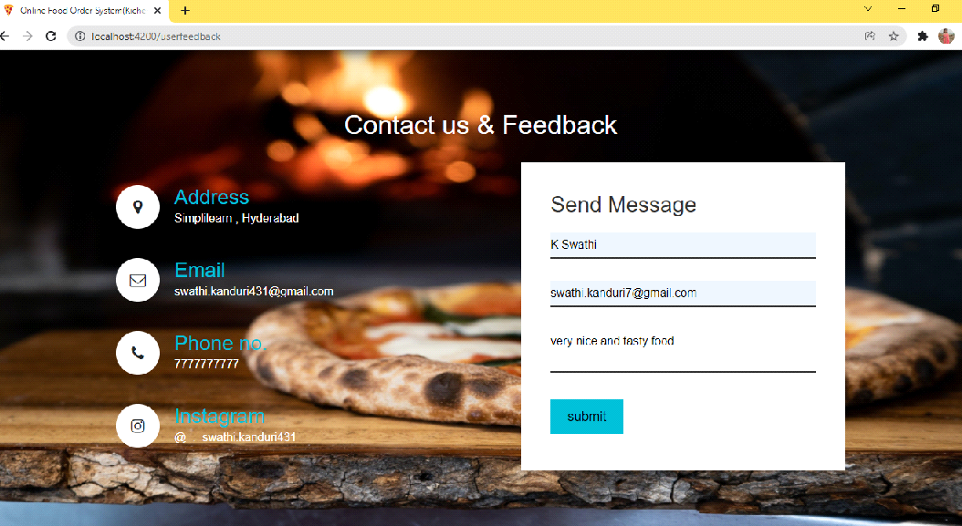

**After adding feedback it will redirect to user home pabe**

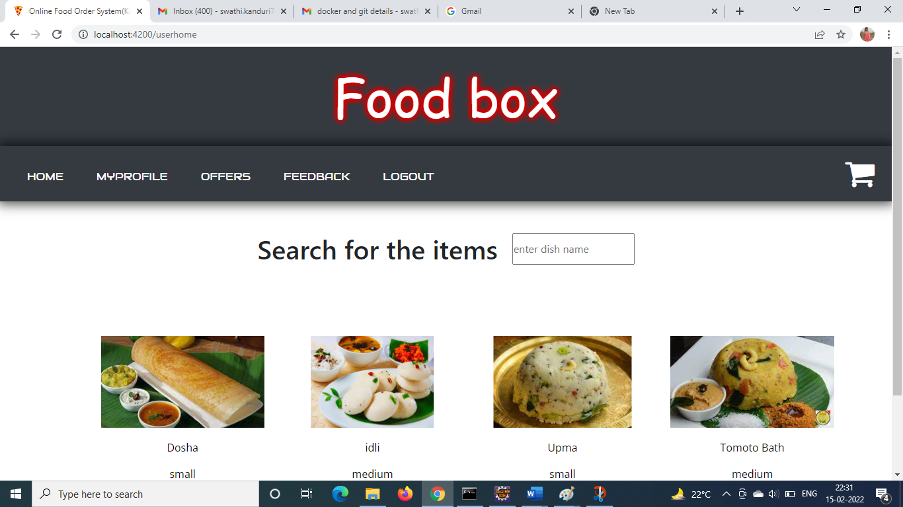

**Logout:-**

